Solar Potential for the Land Recovery, Inc landfill in Graham, Washington.

Demonstration of PVWatts, RE-Powering Mapper, and Re-Powering’s Decision Tree Tool.

Provided by: Karl Oleson

Date: 2/5/24

Contents

Task 1

Executive Summary 1

Background 1

Information from Re-Powering Mapper 3

Information from Re-Powering’s Decision Tree Tool 4

Estimation of the Available Footprint and System Size with PVWatts 5

PVWatts Input Parameters 6

Summary - Yearly Energy Generation Results from PVWatts 6

References 8

Task

Estimate the maximum solar harvesting capability of Land Recovery, Inc.’s (LRI) brownfield landfill site in Graham, Washington as part of the site’s redevelopment plan. Use PVWatts, RE-Powering Mapper, and Re-Powering’s Decision Tree Tool to conduct the analysis.

# Executive Summary

The estimated south facing portion of the landfill covers 54 acres. PVWatts predicted that there is a potential for ~46,000 MWh/year to be harvested from the south facing portion with a 2-axis tracking system. The maximum fixed tilt system is predicted to be ~34,000MWh/year. Analysis with PVWatts recommended a 32.5MW plant while the RE-Powering Mapper recommended a more conservative 24MW installation. Re-Powering’s Decision Tree Tool recommends investigating if the local utility and landowner are open to the project before proceeding further.

# Background

The EPA’s Re-Powering America’s Land Initiative encourages the use of brownfield sites for renewable energy generation. Brownfield sites are abandoned or underutilized properties that may have environmental contamination and can complicate a community’s redevelopment plans (Ecology). Such sites can be found with the U.S. EPA RE-Powering America’s Land Initiative Mapper (mapper). The mapper has information on over 190,000 brownfields, Superfund, landfill, mine sites and other contaminated [lands](https://geopub.epa.gov/repoweringApp/cdn/18/) (EPA, 2024). The mapper also includes initial estimates on the solar production potential of the site.

LRI’s landfill site in Graham, WA is reported as a 320-acre brownfield site with a 168-acre landfill footprint(Pierce, 2024). The contract is expected to be filled/end before 2036. Figure 1 shows the user interface for the mapper. The landfill currently covers the waste material and captures methane to power nearby homes. Figures 2 and 3 show recent aerial photos of the site (Pierce, 2024), (Maps, 2024).

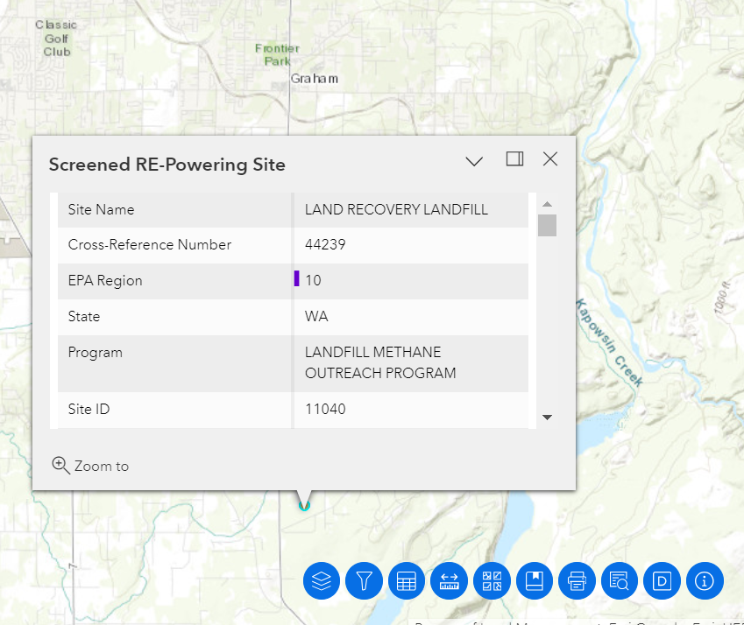

**Figure 1**: Screenshot of the RE-Powering Mapper tool looking at the Land Recovery, Inc’s landfill in Graham Washington (EPA, 2024).

**Figure 2**: Google maps view of the site (Maps, 2024). The south slope should face directly south upon completion.

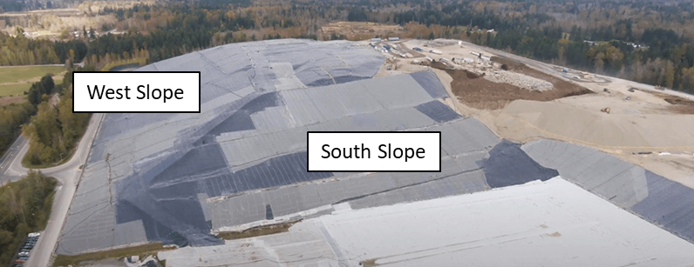

**Figure 3**: Recent aerial picture of the site (Pierce, 2024). The south slope is a candidate for installing solar.

# Information from Re-Powering Mapper

The Re-Powering Mapper contains useful information and initial assessments of the renewable energy potential at brownfield sites. It reports this site is located at 46.971000, -122.290500 and has a potential for 24.35 MW of solar potential. The Maximum Annual GHI (kWh/m2/day) is only 3.31 however, which is below the 3.5 threshold commonly wanted by developers. The mapper further reports the distance to the nearest substation to be 2.15 miles, the substation voltage is at 115V, and the distance to the nearest transmission line is 0.34 miles. Additionally, the distance to the nearest road is reported to be 0.06 miles and the landfill is currently in service.

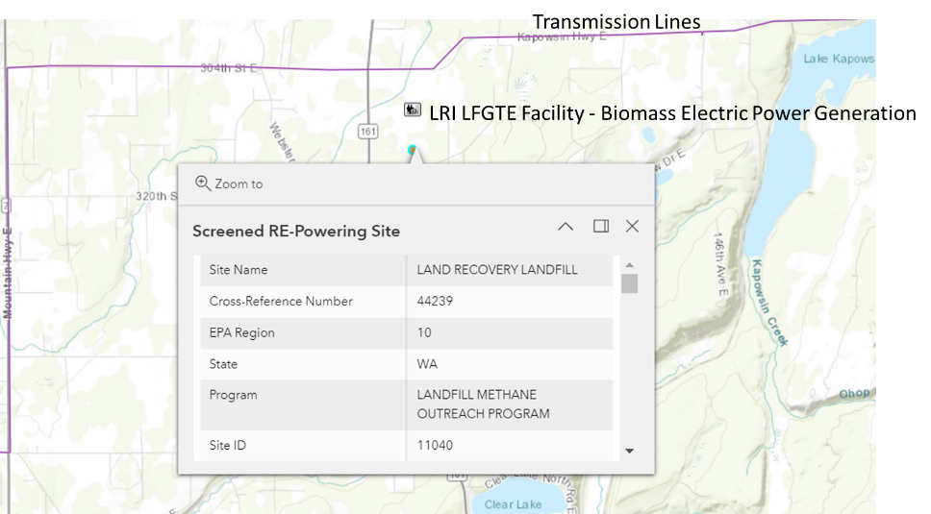

**Figure 4**: Identification of the nearest transmission lines and proximity to an existing biomass electric power generation station.

# Information from Re-Powering’s Decision Tree Tool

RE-Powering’s Decision Tree Tool is a program which helps developers walk through various complications of using brownfield sites for energy generation (EPA, 2023). Below are notable inputs for the Decision Tree Tool. The results from the tool are provided in Figure 5.

* Site Type: Landfill
* Technology: Solar PV
* Installation Type: Ground Mount
* Is this site in the northwest corner of Washington State or Alaska: No
* Enter Usable Acreage (optional): 168
* Is the distance to transmission and/or distribution lines less than 1 mile: Yes
* Enter distance (miles) (optional): 0.34
* Is the distance to graded road less than 1 mile: Yes
* Enter distance (miles) (optional): 0.06
* Is the site owner(s) interested in investing in and/or selling or leasing the site in order to enable development of solar PV: Skip
* Is there an existing redevelopment plan for the site or is one being developed: Skip
* Will a community visioning process be part of the site’s redevelopment: Skip
* Is the site free of land use exclusions or restrictions that would preclude the use of solar PV on the usable acreage or rooftop: Skip
* Is the landfill or portions of the landfill being considered for solar PV closed consistent with applicable requirements: No.
* Is there a closure plan for the landfill: Skip
* Select a renewable energy project arrangement: Sell Power to Utility
* Is the local utility or other energy provider interested in buying power from a renewable project at the site: Skip

**Figure 5**: Results from the Re-Powering ‘s Decision Tree Tool. Further investigation into whether the responsible entities would be interested in this project (redevelopment considerations) is recommended before proceeding.

The tool needs to have more questions answered before a clear determination can be made. The tool recommends filling in missing information such as determining if the local utility is interested in buying the solar energy and if there is an existing redevelopment plan first before approving the project. The tool’s recommended next steps are provided in Figure 6.

**Figure 6**: Reported next steps from the decision tree tool.

# Estimation of the Available Footprint and System Size with PVWatts

The Rooftop Size Estimator in PVWatts was used to draw a perimeter around a site and estimate the site’s footprint. The estimated current size of the active landfill is 651140 m2 (approximately 161 acres). PVWatts further identifies a potential system capacity of 97.7MW in the unrealistic case in which all the area is covered.

**Figure 7**: PVWatts’ Rooftop Size Estimator’s estimate of the area of the site and potential size of a system. Area: 651,140 m2 (approximately 161 acres), power rating: 97,671 kW.

However, it is more realistic to only consider the southern facing side of the mound for solar panel installation. Panels on the east, west, and north slopes are unlikely to be a good return on investment due to shading. A more practical system would cover the southern space outlined in Figure 8. The 216,934 m2 (approximately 54 acres) footprint leads to a PVWatts system size of 32.5MWdc. This more closely matches the 24MW recommendation from the RE-Powering Mapper.

A better estimate of a reasonable footprint should be discussed with Land Recovery, Inc regarding what they expect the future mound to look like.

**Figure 8**: PVWatts’ Rooftop Size Estimator’s estimate of the area of the southern facing slopes of the site and potential size of a system. Area: 216,934 m2 (approximately 54 acres), power rating: 32,540kW.

# PVWatts Input Parameters

PVWatts parameters for the analysis are presented in Figure 9. Results for both 2-axis tracking and fixed tilt scenarios were simulated. The fixed tilt angle was varied from 10ᵒ to 45ᵒ to locate the optimum angle. Default parameters are otherwise used for this quick analysis.

**Figure 9**: Input into PVWatts. Defaults values are used for this initial assessment unless otherwise mentioned. 2-axis tracking and Fixed (open rack) array types were investigated. Tilt degrees of 10-30ᵒ were simulated to find the maximum energy generating angle.

# Summary - Yearly Energy Generation Results from PVWatts

PVWatts predicts a maximum of 46,650,081 kWh/year potential from this site with a 2-axis tracking system. Summary results are shown for the 2-axis tracking system in Figure 10. Various tilt angles were investigated for a fixed tilt system and the results of different tilts are shown in Figure 11. Using a fixed system shows an optimum at 33,946,028 kWh a year at 30ᵒ tilt.

According to energysage.com, the average Washington household uses 11,736 kWh/year (energysage, 2024). The recommended 32kW solar plant with 2-axis tracking system could provide electricity for 3,975 homes. A fixed tilt system could provide equivalent electricity for 2,892 homes.

**Figure 10**: Output from PVWatts with 2-axis tracking system. An annual production of 46,650,081 kWh/year is predicted.

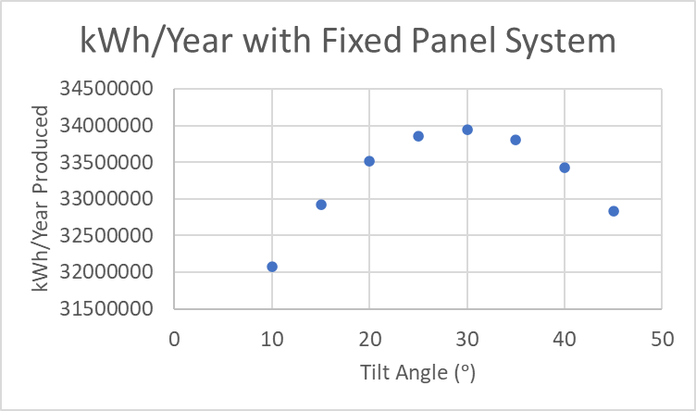

**Figure 11**: Plot of Tilt Angle vs. kWh/Year Produced for a fixed tilt system. A tilt angle of approximately 30 degrees is recommended with 34,000,000 kWh a year of solar potential.

# References

Ecology. (n.d.). *Brownfields in Washington.* State of Washington Department of Ecology. Retrieved from ecology.wa.gov/spills-cleanup/contamination-cleanup/brownfields#:~:text=Brownfields%20in%20Washington,smelters%2C%20or%20former%20agricultural%20land

energysage. (2024). *energysage - See how much solar can save you*. Retrieved from https://www.energysage.com/local-data/electricity-cost/wa/#:~:text=That's%2028%25%20lower%20than%20the,the%20course%20of%20the%20year

EPA. (2023). *EPA - RE-Powering America's Land*. Retrieved from RE-Powering's Electrionic Decision Tree: https://www.epa.gov/re-powering/re-powerings-electronic-decision-tree#:~:text=Developed%20by%20US%20EPA's%20RE,solar%20photovoltaics%20or%20wind%20installations.

EPA. (2024). *U.S. EPA RE-Powering America's Land Initiative Mapper*. Retrieved from https://geopub.epa.gov/repoweringApp/

Maps. (2024). *Google Maps*. Retrieved from 46.971553, -122.290575: www.google.com/maps

Pierce. (2024). *Pierce Country Landfill Information*. Retrieved from www.piercecountywa.gov/7972/Landfill-Information